3.1 The .NET Framework 2
3.1.1 Providing a common runtime environment 3
3.1.2 A wealth of libraries 4
3.2 A runtime for dynamic languages 5
3.2.1 There is only one true object 5
3.2.2 It’s all about messages 6
3.2.3 Hosting the DLR in your applications 7
3.3 Windows Presentation Foundation (WPF) 8
3.3.1 XAML: Development: now assimilating designers 9
3.3.2 A simple browser example 10
3.4 Silverlight 13
3.4.1 What’s in it? 14
3.4.2 Why should I care? 15
3.4.3 How do I use it? 16
3.5 ASP.NET 16
3.5.1 Webforms, the classic way of using ASP.NET 16
3.5.2 ASP.NET MVC, new and improved 16
3.6 Summary 17

3
.NET putting the Iron in IronRuby
This chapter covers:
- Components of the .NET Framework
- WPF for building fat clients
- Silverlight for building rich internet applications
- ASP.NET family for creating internet applications

When Microsoft announced the .NET framework, my colleagues were absolutely stoked because it would solve a lot of versioning issues with dll’s. It was going to be something that would allow people to write libraries in one language and use them in another. Those things sounded like pretty cool features to me. I started learning VB. NET and quickly after that switched to C# because it feel more natural to me. The beauty of .NET was that whatever libraries I learned when using VB.NET I could just use that knowledge in C# without having different interfaces to classes etc.
So far we’ve covered the differences in typing systems between a classical .NET language, for which we used C# as an example of a canonical static language, and the ruby language. In the next chapter we talked about the ruby language and some of the cool things you can do in Ruby. This chapter is about the .NET Framework and how it ties in to IronRuby, why it’s a good thing. But before that I’ll have to go through what the .Net Framework actually is, what the DLR does for you. We’ll also look at what WPF is and does for you. After which we’ll explore the technologies .NET offers you to leverage the internet.
Most of the samples from this chapter should run both on mono and on the Microsoft .NET framework. The samples that utilize WPF won’t run under mono because at the time of this writing mono doesn’t have an implementation of the presentation framework in the olive project. If you don’t know what Mono is don’t worry I’ll explain it later in this chapter.
But let’s get started at the beginning and briefly explain what the .Net framework does and is.
3.1 Exploring the .NET Framework
The .NET framework is the single best invention Microsoft has made for developers. It was designed with several goals in mind. It had to be portable across platforms, to be language independent, to simplify deployment and to be secure. Interoperability was also a major concern for the team that designed the .NET framework. To meet these ambitious design goals they came up with something pretty nifty. The framework consists out of 2 major parts: a common runtime engine and a base class library. The Microsoft .NET framework implements those parts as the Common Language Runtime and the .Net Framework class library. Because it’s a Microsoft tool it’s designed to run on windows, although Microsoft is now working on a version that will run on Mac OSX.
In the mean time for people that don’t run windows there is Mono. Mono is an open-source implementation of a set of .NET compatible tools that runs on a wide range of operating systems. To provide these original design goals every language that runs on top of the .NET Framework compiles down to a Common Intermediate Language (CIL) that gets translated by the Common Language Runtime for the specific platform it’s running on, as shown in Figure 3.2.
Figure 3.1 shows a high-level overview of how the .NET framework ties into the windows operating system. This picture shows on the left side how managed applications get to the operating system and on the right side there is a special case for running ASP.NET applications in Internet Information Services (IIS).

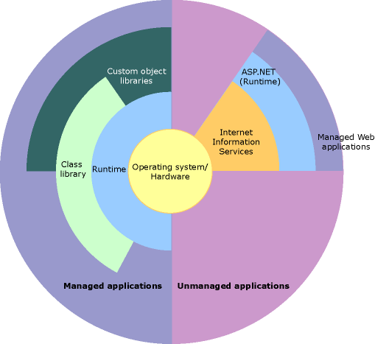

Figure 3.1: This is how the Microsoft .NET Framework integrates into the windows operating system.

The next parts of this section will first look a little bit closer at the Runtime and next at the Framework Class libraries. The runtime environment functions as a virtual machine that is able to optimize the managed code for the specific platform it’s running on. For the remainder of the book I’ll be talking about the Microsoft .NET Framework, but most of the samples and topics should work on mono as well.
3.1.1 Providing a common runtime environment
The common runtime environment is mostly referred to as the Common Language Runtime (CLR). The DLR is responsible for compiling the generated CIL code into machine-readable code (figure 3.2). Because the runtime is running on the actual machine it is executing code on and because the CLR does something called Just-In-Time compilation the CIL compiler has a lot of information available at run-time and can thus provide highly optimized code for the current platform. In my opinion that is great, but there is a downside to this. It also means that before your application starts the CLR has to be loaded first to execute your .NET code. This causes a slight delay in startup time.

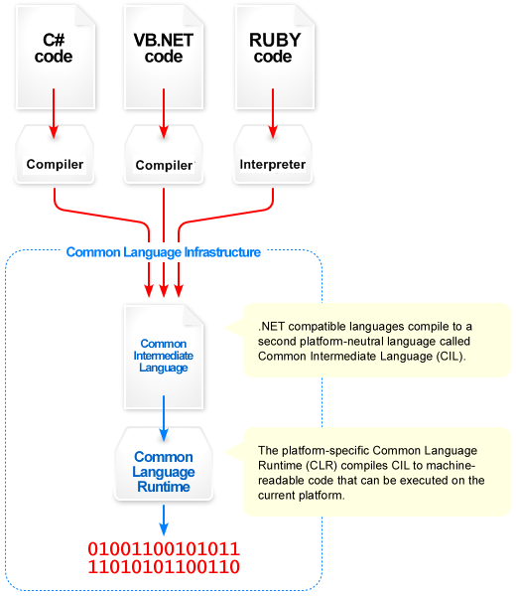
Figure 3.2: An overview of how the CLR translates your code into machine code

In addition to compiling the CIL code the CLR has more features like memory management, thread execution and others like code access security etc. The runtime enforces code robustness by implementing a Common Type System (CTS). This type system ensures that all managed code is self-describing, which allows for your library to be used in a different language and still enforce type-safety.
Now let’s deal with the base class libraries and why that can be a good thing in the IronRuby world. To send an email for example you typically have to rely on a 3rd party library that encapsulates that process for you so you don’t have to deal with the SMTP protocol directly. The .NET framework implements a ton of those libraries that you can use for free in IronRuby.
3.1.2 A wealth of libraries
The second part of the .NET Framework are the Base Class Libraries (BCL) and the Framework class libraries. These libraries make an otherwise difficult task drastically easier to implement. Some of these tasks include sending emails, perform data access to a bunch of data sources, building a web application or a web service. These libraries also provide facilities to build console applications and GUI applications and many others.
The scope of the base class library is much larger than the standard libraries for other languages. The base class libraries are simply brilliant because it allows me to do most of the most common tasks on virtually any platform from one language with one and the same library and generally configuration. In addition to being a very rich library the quality of the library is extremely high and fairly rich in functionality. And on top of that there is also a large eco-system out there with more 3rd party libraries that perform almost every task you’ll need.
And because all of those libraries run on the CLR it doesn’t matter in which language the library is implemented you can just use it all the same. To me this is the best strength of the whole .NET experience, you can program in any language I want as long as it’s implemented on .NET. And I can ship my compiled binaries to clients and other developers and they can use them in the language they want.
Now that we know how the .NET framework does its thing let’s take a closer look at the Dynamic Language Runtime (DLR), which is a runtime that runs on top of the CLR and provides facilities for dynamic languages to run on the .NET framework.
3.2 A runtime for dynamic languages
When we’re talking about essential building blocks of the .NET Framework in the context of dynamic languages there is a third building block. In addition to the CLR and BCL there is also a Dynamic Language Runtime (DLR). The DLR are a set of services that run on top of the CLR and provide facilities like a hosting API, a dynamic type system, dynamic method dispatch and dynamic code generation. These services are language agnostic and are meant to make it easier for language developers to implement their language on top of the .NET framework.
The shared dynamic type system allows you to freely share code with other dynamic languages as well as with the static languages implemented on the .NET Framework. The most important bit of the previous sentence was that you can share code with any language that is running on the CLR or DLR.
A second great benefit of the DLR is that the language implementer gets a whole bunch of stuff for free like a Garbage Collector for example. Any optimizations that Microsoft performs in the DLR are automatically incorporated in the languages implemented on top of it. Previously I did mention the wealth of libraries you have at your disposal, these are still available and can also make a lot of difficult tasks really easy to perform, in a dynamic language. Obviously you would have to write less code to get there but that’s a nice side effect from dynamic languages.
There are a couple of things worth knowing about the DLR which we’ll discuss in this section of this chapter. The first topic is going to be the shared dynamic type system because it’s a corner stone of the DLR and the second topic is on how the DLR thinks about its types.
3.2.1 There is only one true object
Probably the most important of the services the DLR implements is the shared dynamic type system. This system lets the languages easily talk and share information with each other. This ensures that the dynamic languages can use the existing and future wealth of .NET libraries out there in the wild.
Because in the past, a lot of dynamic languages have been implemented in different languages through a pattern that uses wrappers and marshalling layers. Figure 3.3 shows how Jython, a python implementation, was implemented in Java.

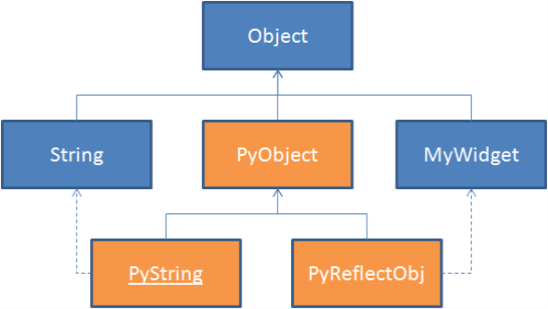
Figure 3.3: The way Jython handles its types, implemented as a pattern of wrappers and marshalling layers

This standard pattern is a decent solution as long as you’re interested in supporting a single language and is necessary because a lot of languages don’t have such a rich runtime type information system as the CLR has. And that is the reason why the .NET implementation isn’t bothered by the necessity for wrapping and marshalling of the objects. A type in the DLR is exactly the same as a type in the CLR as shown in figure 3.4.

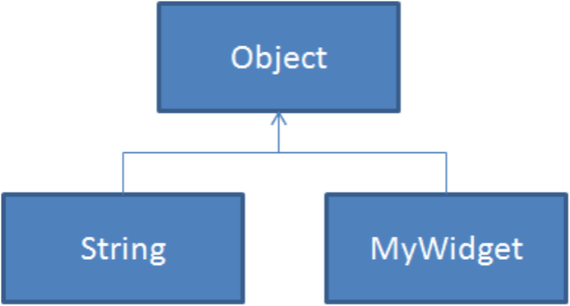
Figure 3.4: This is the basis of how the DLR is able to easily share its types across languages, notice the lack of wrappers and marshalling layers.

This should give you an understanding on how nicely integrated the languages are. Later in this section we’ll look at how this sharing works with a concrete example. But before that I want to draw some attention to how the DLR deals with invoking methods and properties etc on objects in both static and dynamic languages.
3.2.2 It’s all about messages
As you might know or may have guessed most languages have their own specific ideas about what a type is and how that type should invoke its member methods or properties. Trying to provide a layer for each of the language that uses the specific type systems for each of them would be super complicated. However when you look at the core of object oriented systems you’ll notice that all languages have significant commonalities if you view them at the object based, message passing level. This implies that the DLR focuses on the object based, message passing level and treats every instruction as a message that’s being sent to an object as shown in figure 3.5. This way the team only had to cater for 2 typing systems: the static type system and the dynamic one.

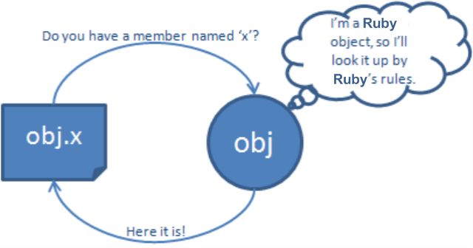
Figure 3.5: The DLR focuses on sending messages to objects
When the type belongs to one of the statically typed languages of the CLR, all the type information is present and a message of GetMember does a lookup on that type in its fields, properties and methods. When it can’t find the member, it will throw an error; otherwise, it will return the member so that it can be invoked.
For dynamic types on the other hand the team took a different approach where a dynamic type implements a special interface IDynamicObject, which provides customized handling for all the dynamic operations. This is to ensure that the dynamic object will play by the rules regarding member invocation in the DLR. That IDynamicObject interface is implemented on the base type of each of the supported languages so that all the objects created in that dynamic language will be able to talk to any other type that runs on the CLR.
That is all you should know about the DLR unless you want to implement your own language on top of it but in that case I suggest you contact somebody from Microsoft that can help you to get you on your way. The next part of this section in this chapter is about hosting the DLR in your own applications.
3.2.3 Hosting the DLR in your applications
The DLR team has prepared a couple of hosts for you to which we’ll return later in this chapter but we need to talk about hosting the DLR in one of your own applications so that you’re able to extend your existing .NET applications with IronRuby if you so desire.
In addition to the Shared Dynamic Type System; the DLR also has a shared dynamic host system, which takes care of executing code in the DLR from your application. These allow you to execute your IronRuby code, for example, in a managed application. They can also allow your code to interact with libraries and share types with the application that is hosting the DLR. This can go pretty far, it can even go across AppDomain boundaries. Microsoft provides a couple of precooked hosts, like one for Silverlight, ASP.NET (MerlinWeb), Console applications etc.
These hosts are also responsible for providing intellisense inside an IDE like visual studio. This integration is what should give you intellisense, a rich debugging experience and lots more nice goodies. Code listing 3.1 shows how to host the DLR in a console application and then have it execute some ruby code in the context of that application.

Listing 3.1: Hosting the DLR in one of your applications
//TODO: review this when the hosting api changes.
IScriptEnvironment runtime = ScriptEnvironment.GetEnvironment();

Console.WriteLine("Executing from file:");
runtime.ExecuteFile("..\\..\\hello_world.rb");

// Outputs the following:
//
// Executing from file:
// hello, world!

The code listing above shows how to host the IronRuby engine inside a runtime (DLR). We load a ruby source file hello_world.rb and execute it inside the script environment. The hello world file contains one line of code: puts ‘Hello, World!!!’. The next code listing 3.2 shows how you can pass a list of strings from your c# console application to a ruby script running inside that application.
I’ll give some more examples of mixing languages later in this chapter, because it’s possible to use a number of scripts all written in a different language that is supported on the DLR and use all of those scripts inside a ruby file for example.

Listing 3.2: Passing a list of strings to a ruby script created from a string and execute that script
//TODO: review this when the hosting api changes.
IScriptEnvironment runtime = ScriptEnvironment.GetEnvironment();
IScriptEngine engine = IronRuby.GetEngine(runtime);
IScriptScope scope = engine.CreateScope();

List<string> strings = new List<string>();
strings.Add("Hello, ");
strings.Add("World!!!");
IronRuby.GetExecutionContext(runtime).GlobalVariables[SymbolTable.StringToId("strings")] = strings;

SourceUnit script = engine.CreateScriptSourceFromString(
@"
puts "" There are #{$strings.count.to_s} strings:""
$strings.each_with_index { |s,i| puts ""#{i}: #{s}"" }
");

Console.WriteLine("Executing from string:");
engine.Execute(scope, script);

// Outputs the following:
//
// Executing from string:
// Hello World! There are 2 strings:
// 0: Hello,
// 1: World!!!

The listing above is slightly more complicated and demonstrates how we can control the scope in which the script will be executed within the DLR. It also shows how we can just take a string as a ruby script and execute that in with the IronRuby engine. We create a list of strings and pass that list to the global variables collection in the current execution context. Then in the ruby script we use that list of strings as a global ruby variable.
This should give you some idea of what was involved in creating the DLR and why it’s nice to be able to work with it. The next part of this chapter will deal with some of the technologies we’ll be using later on in the book so that you have an idea of how somebody could go about building a real world application using IronRuby. The first technology I would like to investigate is Windows Presentation Foundation (WPF) a framework for developing desktop applications.
3.3 Windows Presentation Foundation (WPF)
Windows Presentation Foundation (WPF) is being used to create rich and stunning desktop applications. It was designed to provide a uniform and easy way of creating nice effects and having a totally customizable toolset.
WPF is vector based for the most part which means that no matter how big the screen is the images etc will always look crisp and beautiful. It is very capable of doing 3D animations and such because it uses the GPU of the video card so that the main CPU isn’t blocked by doing animations. It is fully hardware accelerated which means that you enjoy the same power a game does. I think that’s pretty cool stuff. And what makes it even cooler it’s really easy to use it from IronRuby.
WPF uses a markup language that’s called eXtensible Application Markup Language (XAML) which allows for a bunch of tasks to be done declaratively. We’ll look into XAML a little bit closer in a minute. In addition to using the XAML format (which is by far the easiest way to do things in WPF) you can use any .NET language, including IronRuby, to build up WPF based GUI’s (Graphical User Interface). There is one caveat at the moment of this writing mono doesn’t support WPF completely, but that will change in the future.
The knowledge you gain from using WPF is mostly transferrable to Silverlight. Silverlight or Moonlight on mono, understands XAML etc but runs inside the browser (currently supported browsers: Firefox, safari, Internet Explorer). Silverlight is a really cool piece of technology and we’ll be investigating that properly later on in this book.
Explaining you everything you can do with WPF is out of the scope of this book. There are several really good books on this subject and they will do a much better job at explaining you the nitty gritty of WPF programming. I will however show you the possible ways of running WPF with IronRuby and we’ll use those techniques later on in this book when we’ll be building an application. The first thing I want to walk through with you is XAML.
3.3.1 XAML: Development: now assimilating designers
Oh my god!!! I thought this was a book on IronRuby and so far I’ve seen a lot of samples in C# and it looks like they’re going to be in some form of XML. I have the same feeling here and you are correct to be assuming this but I want to assure you that this book is about IronRuby, and the samples from now on will be almost all in the Ruby language. I need to show you some samples in other languages later just for the sake of demonstrating that you can.
There are a couple of reasons why I want to talk about XAML in this book. The first reason is that XAML is a way for interfaces to be created by designers in Illustrator for example and then through a tool they can be turned into XAML. That XAML can then be used immediately by you the developer to make the interface do some actual work. Using XAML has some distinct advantages over most imperative programming languages but anything you can do in XAML can also be done with an imperative programming language like IronRuby but not vice versa.
XAML is usually the most concise way to represent user interfaces and other hierarchies of objects. Because of the fact that it is XML based, one its strongest points is probably the ease of representing highly related data. Using XAML promotes a clear separation between your front-end appearance and your backend logic which provides easier maintainability.
XAML is primarily used for creating and initializing objects. Because interfaces represent mostly very hierarchical data, XML is a good fit for representing that data because the nesting of tags can mimic the hierarchy easily. That being said I want to repeat that anything you can do in XAML you can also do in IronRuby.
The next part of this wpf section will first show an example in XAML of how you could create your own simple browser, and after that we’ll take a look at a translation of that XAML to IronRuby. Later on in the book we’ll take a closer look at how I think IronRuby and XAML will be used to develop desktop applications; which is a kind of middle ground between both worlds.
3.3.2 A simple browser example
In this section we’ll take a closer look at some the possible ways you can WPF from IronRuby. The first way we’re going to see is by creating the layout in XAML first (listing 3.3) and then loading that into an application from IronRuby. The second way is by using IronRuby to build up the layout from code.
The example we’ll be creating is a simple browser application with an address bar, a button to fetch a page and a frame that will display the webpage.

Listing 3.3: The XAML for defining the layout of the browser application

<Window xmlns="http://schemas.microsoft.com/winfx/2006/xaml/presentation"
xmlns:x="http://schemas.microsoft.com/winfx/2006/xaml"
Title="Biffy" Height="500" Width="826" x:Name="root" >

<DockPanel x:Name="dock_panel">
<TextBlock FontSize="36" Background="AliceBlue" DockPanel.Dock="Top">Biffy</TextBlock>
<StackPanel Orientation="Horizontal" DockPanel.Dock="Top">
<TextBox x:Name="web_url" Width="750">http://blogs.msdn.com/dsyme/archive/2007/10/26/expert-f-available-by-end-of-november.aspx</TextBox>
<Button x:Name="get_url_button">Show Url</Button>
</StackPanel>
<Frame x:Name="web_url_display" Source="http://blogs.msdn.com/dsyme/archive/2007/10/26/expert-f-available-by-end-of-november.aspx"></Frame>
</DockPanel>
</Window>

Listing 3.3 shows us the XAML that describes the window we want to display by nesting a dock panel in the window, showing a title bar (TextBlock) and a stack panel with the actual GUI elements. Listing 3.4 shows how we would use the previously created XAML from IronRuby.

Listing 3.4: The Ruby code to show the XAML and attach an event to the button

p "loading components, please wait..."

# get the necessary assemblies loaded for .NET 1
require 'mscorlib'
require 'System, Version=2.0.0.0, Culture=neutral, PublicKeyToken=b77a5c561934e089'
require 'System.Xml, Version=2.0.0.0, Culture=neutral, PublicKeyToken=b77a5c561934e089'
require 'PresentationFramework, Version=3.0.0.0, Culture=neutral, PublicKeyToken=31bf3856ad364e35'
require 'PresentationCore, Version=3.0.0.0, Culture=neutral, PublicKeyToken=31bf3856ad364e35'

# include some namespaces for easy access 2
include System
include System::Windows
include System::Windows::Controls
include System::Windows::Markup
include System::Windows::Media
include System::Windows::Media::Animation
include System::Xml

# define an application 3
class XamlApplication < Application

def initialize
run yield
end

end

#run the application 4
xaml_path = "Biffy.xaml"

XamlApplication.new do
obj = XamlReader.load XmlReader.create(xaml_path)

obj.find_name('get_url_button').click do
obj.find_name('web_url_display').source = obj.find_name('web_url').text
end
obj
end

1 load the .Net framework libraries
2 include some helpers
3 define an application
4 run the window and attach the click event

In listing 3.4 there are 4 important sections. This is also the first time that we actually get to use .NET from the Ruby language so let’s investigate #1 a little bit closer. To get access to the basic .NET types we need to load the file mscorlib, but that is just a very limited set of classes the absolute minimum that is required to have .NET going on a machine. So we load a couple of extra assemblies where the assemblies whose names start with Presentation are WPF specific assemblies. This first step ensures that we have the necessary type information available for using WPF and XAML.
The second part #2 provides access to types that live in the specified namespaces without having to specify the fully namespaced type all over your code. So it allows you to write Application instead of System::Windows::Application. On to part 3 then shall we. This is standard WPF programming. In #3 we create a class that inherits of Application to encapsulate our own application logic. The code that we have in that class expects a block for the constructor and that block should return a Window object which we’ll run.
The last section of the code in listing 3.4, section #4 is the code required to start our application. That is where the actual work is done. We first read in the XAML document which will return us the window object. Next we need to attach a click handler to the button that will change the url of the frame so that we can browse the internet.
Listing 3.5 shows how we would go about creating the exact same application but by using the Ruby language to program the interface instead of XAML to describe it.

Listing 3.5: Creating the browser application by using only Ruby

p "loading components, please wait..."

# get the necessary assemblies loaded for .NET
require 'mscorlib'
require 'System, Version=2.0.0.0, Culture=neutral, PublicKeyToken=b77a5c561934e089'
require 'System.Xml, Version=2.0.0.0, Culture=neutral, PublicKeyToken=b77a5c561934e089'
require 'PresentationFramework, Version=3.0.0.0, Culture=neutral, PublicKeyToken=31bf3856ad364e35'
require 'PresentationCore, Version=3.0.0.0, Culture=neutral, PublicKeyToken=31bf3856ad364e35'

# include some namespaces for easy access
include System
include System::Windows
include System::Windows::Controls
include System::Windows::Markup
include System::Windows::Media
include System::Windows::Media::Animation
include System::Xml

my_window = Window.new
my_window.title = 'Biffy'
my_window.height = 500
my_window.width = 826

my_dock = DockPanel.new
my_window.content = my_dock
header = TextBlock.new
header.background = Brushes.AliceBlue
header.font_size = 36
header.text = "Biffy"
DockPanel.set_dock header, Dock.Top

my_dock.children.add header

start_url = "http://blogs.msdn.com/dsyme/archive/2007/10/26/expert-f-available-by-end-of-november.aspx"

top_stack = StackPanel.new
top_stack.orientation = Orientation.Horizontal

feed_url = TextBox.new
feed_url.text = start_url
feed_url.width = 750
DockPanel.set_dock top_stack, Dock.Top

load_feed_button = Button.new
load_feed_button.content = "Show site"

top_stack.children.add feed_url
top_stack.children.add load_feed_button
my_dock.children.add top_stack

frame = Frame.new
frame.source = Uri.new start_url

my_dock.children.add frame

load_feed_button.click do |event, args|
frame.source = Uri.new feed_url.text
end

my_app = Application.new
my_app.run my_window

By just using imperative code we immediately lose some of the advantages we have from XAML. The first one would be that we don’t have an overview at a glance of how the hierarchy of the interface works. Second how did those couple of lines of XAML become so many lines of Ruby code? Wasn’t XML supposed to be the verbose language and Ruby the beautiful language? What’s going on here? We are working with the direct API’s of windows presentation foundation. These have been built purposely to accommodate for XAML, in fact the API’s are often a consequence of the fact that it uses XAML. With Ruby, of course we can do better than just using the native API’s. Why don’t we sprinkle some meta-programming over that code and see where we end up. Listing 3.6 shows the result, for brevity I haven’t included the code that makes that possible in the book but it is available with the code samples for this book.
Listing 3.6: Programming a wpf interface after meta-programming

p "loading components, please wait..."

require 'wpf'
require 'wpf_elements'

class WpfApplication < Application

def initialize()
run yield
end

end

start_url = "http://blogs.msdn.com/dsyme/archive/2007/10/26/expert-f-available-by-end-of-november.aspx"
title = "Biffy"

WpfApplication.new do

# build the window
obj = Wpf.build Window, :title => title, :height => 500, :width => 826, :name => "Biffy" do
add DockPanel, :name => "dock_panel" do
add TextBlock, :text => title, :font_size => 36, :background => :alice_blue, :dock => :top, :name => "text_block"

add StackPanel, :orientation => :horizontal, :dock => :top, :name => "stack_panel" do
add TextBox, :text => start_url, :width => 750, :name => "web_url"
add Button, :content => "Show site", :name => "get_url_button"
end

add Frame, :source => start_url, :name => 'web_page_display'

end
end

# attach the event handler
obj['get_url_button'].click do
obj["web_page_display"].source = obj["web_url"].text
end

obj
end

In listing 3.6 above we do exactly the same thing but in this case I’ve used a module, that John Lam built for a presentation at RubyConf, to build up the interface. I had to put this code in to show that there is still hope left. This preserves the fact that we can see the hierarchy of the interface and it’s slightly less verbose than the xml we generated. This has an extra advantage; the CLR doesn’t have to perform a XAML parse and compilation step before it can display the interface. When I would be building a WPF app I would probably combine the first and last approach
This concludes are brief introduction to what WPF is and how to use it from Ruby, there are many avenues we haven’t explored yet. The book isn’t over yet and we’ll see some more stuff on WPF later on. The next part of this chapter will talk briefly about Silverlight, and the MVC frameworks we’ll be using later on in the book. We’ll also have a brief discussion on the possible approaches to ORM’s that are available to us in IronRuby.
3.4 Silverlight
If I would have to describe my opinion about Silverlight in one word I would have to say: Awesome! From all the technologies mentioned in this book I think Silverlight takes the cake. I’ll try to convey this feeling to you, because this is where I think web development could get so much more fun and cool at the same time. But let’s first start by explaining what Silverlight actually is and then moving on to why it’s so cool.
I can’t get around the compulsory definition for this one, here it goes. Microsoft Silverlight is a cross-browser, cross-platform plug-in for delivering the next generation of .NET based media experiences and rich interactive applications for the web. That’s cool but bear in mind that at the time I’m writing this book Silverlight runs on Windows and Mac OSX but not Linux. Again I’ll mention Mono for people that are running Linux. Mono has an application called Moonlight which is roughly the same thing. They should be completely compatible to each other. I think this is a pretty sweet deal because you can develop your applications and be sure they will work in IE, Safari and Firefox without even having to worry about any inconsistencies that exist in the different browser implementations.
So let’s take a closer look at what’s in Silverlight to find out a little bit more about its architecture and different components. Just to be clear we are talking about Silverlight 2.0 here, because Silverlight 1.0 does purely JavaScript and HTML.
3.4.1 What’s in it?
The Silverlight platform has 2 major parts (figure 3.6): the core presentation framework and the .NET Framework for Silverlight. The core presentation framework provides components and services to build your UI. It contains controls for user input, media playback … In addition to the controls it also provides a DOM API for the Canvas and XAML support for creating your interface. The .NET Framework for Silverlight is a subset of the .NET framework that contains a bunch of libraries for common tasks, the DLR and the CLR.

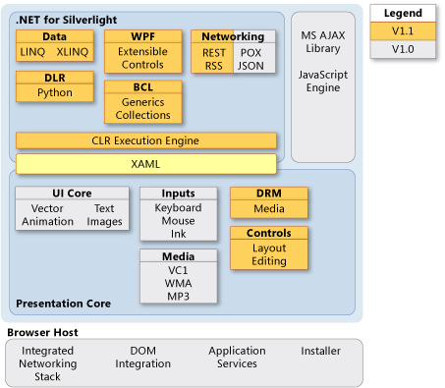

Figure 3.6: From Silverlight v2.0 there is support for dynamic languages. We can also see how all the components fit together

The picture of the architecture holds a bunch of items that I am personally looking forward to for doing development. The ability to use a language like IronRuby to program both the server side and the client side would be one of the most important ones, followed closely by the ability to program on top of the CLR and have everything expressed with WPF controls. I think all the components are fairly important however the ones I mentioned before are the ones that made me want to take a really close look at what Silverlight could mean for me. I’ve put all the components of Silverlight in table 3.1.

Table 3.1: The components of Silverlight
Core Presentation Framework
Input | Handle input from hardware devices
UI Rendering | Renders vector and bitmap graphics, animations and text
Media | Features playback and management of audio and video files
Controls | Provides controls to rapidly built applications
DRM | Enables DRM on media assets
XAML | Provides a parser for XAML markup
.NET Framework For Silverlight
WPF | A subset of the full blown WPF framework for the desktop
Data | Support for LINQ and XLinq, to ease working with data
BCL | Provides essential programming functions
Networking | Simpler access to remote services and data
CLR | Common Language Runtime for memory management etc.
DLR | Support for Dynamic languages on the CLR
Additional API Features
Isolated Storage | Enables safe local storage and caching of data for a particular user
Asynchronous programming | The work is done on a background thread keeping the UI responsive
File management | Provides a safe File Open dialog box to make uploading easier
HTML – managed code interaction | Enables DOM manipulation through a .NET API
JSON support | Allows access to ASP.NET web services
POX services | Enables calls to simple XML based web services
XML Libraries | XMLReader and XMLWriter to simplify working with XML Data

I think this is a pretty compelling list of features for web development; it solves some of the problems that the larger applications and sites are struggling with like isolated storage and some access to the local file system of the person viewing your site. You can just program it using IronRuby which is a big bonus if you ask me. This means that both the client and server side can be programmed in the same language. What’s more is that you can just mix and match languages. An IronRuby file can for example just require a vbx file and access all the types and methods etc created by that file, very handy under the best tool for the job motto.
3.4.2 Why should I care?
If you’re doing web development you should definitely care about this. It allows you to target the major browsers without having to worry about how things will look in each of them. It will always look the same. The same goes for providing a richer interaction with the user. In recent years web applications have used HTML and JavaScript through a technique called AJAX for providing those experiences often in combination with Adobe Flash. There are a number of problems with the current approach of developing those rich internet applications. It makes development pretty complex because if you want to stand your ground as a web developer you need to be able to program in at least 5 languages: HTML, JavaScript, CSS, SQL, Server side language (Ruby, Python, C#,…).
Every browser implementation has its own ideas around how html and JavaScript should be implemented which often makes an application run really well in one browser but not that good or not at all in another one. Often the JavaScript engines are slow so there is a limit as to how much functionality you can put in your application before it gets hairy. JavaScript is single threaded and sometimes you just need more. Flash can be used to fill that gap but that adds yet another language (ActionScript) to your requirements. In short we could use some innovation in this area. Silverlight could just be it.
3.4.3 How do I use it?
Now that we know what it is and why it can be a big thing soon, maybe it’s time to check out how to use this thing. As an example we’re going to build a client that will consume a flickr feed and display the pictures in an animated slideshow. We’re going to code the Silverlight application with a combination of XAML and IronRuby.

TODO: Actually put a working sample here. Currently there is no Silverlight version that supports IronRuby.

This was a short example on how you can achieve some cool things with Silverlight and IronRuby. I believe that Silverlight will be a significant player on the web in a couple of years and that the strength will come from combining it with html based pages. The next section will deal with creating web pages with ASP.NET, the combined services for the web from the .NET Framework
3.5 Developing for the web with ASP.NET
Of course just Silverlight won’t be enough to develop web applications. We will still have to face generating HTML. The .NET Framework has 2 components that accommodate this. It has Webforms and an MVC Handler. ASP.NET is a set of components and services that are used for doing web development with the .NET Framework.
This book will use the tools provided by the Rails framework side by side with the MVC approach for IronRuby. In the code samples that accompany there is also an implementation that uses Webforms. I prefer to use an MVC type model when I’m creating websites but realize that some people will want to see how the code looks in a classic ASP.NET website. Let’s take a closer look at the differences between the approaches.
3.5.1 Webforms, the classic way of using ASP.NET
From the start the .NET Framework has supported using Webforms for developing web applications. Webforms were specifically designed to ease the transition for windows developers to the web. It uses controls and a concept of a page life-cycle in combination with ViewState and ControlState to make the web appear stateful.
You don’t have to use any of the mentioned components if you don’t want to but then it does get a bit tedious when you have complex forms. I have been developing web applications for about 10 years now and I like the webforms way of doing things if you have a small application where you don’t need a lot of AJAX interactivity. For more complex applications I look at an MVC framework like Castle/MonoRail, Spring.NET or ASP.NET MVC.
Let’s look at an example on how we can bind a grid to show us the content of an XML document. The document only holds a list of names of people and their age. You can do this completely declaratively but I want to demonstrate how to use some of the controls from code.

TODO CODE LISTING FOR AN ASPX PAGE WHEN THERE IS SUPPORT FOR IT

And that’s how you would go about creating web pages with ASP.NET and IronRuby. That’s already pretty cool, but there is an alternative to web forms. This alternative is called ASP.NET MVC and we that’s what we’ll be talking about next.
3.5.2 ASP.NET MVC, new and improved
Very recently Microsoft has been building an MVC (Model-View-Controller) handler for ASP.NET. Using an MVC approach to web development makes sense and improves testability. I think it’s always good to have better and easier ways to test your work. It also forces you to have a very clean separation of concerns. By that I mean performing your maintain your state in your models, often that state is persisted to the database. Views are representations or the components that display the data. And the Controller part takes care of handling user input, passing that on to the models and then it decides which view it’s going to render with the data it collected from the models.
I personally have been developing applications with this methodology on .NET for the past 2 years and really like it. I definitely like the ASP.NET MVC Framework because it’s highly extensible. You have full control over how you want the MVC Framework to behave. And it integrates seamlessly with existing ASP.NET applications. You still get to use controls if you want to but there is no more ViewState and you don’t have to use them. There are already a couple of alternative view engines for the ASP.NET MVC Framework. These can be found in the mvccontrib project on codeplex.
Now that we know what the MVC Framework is and how it’s a very nice way of implementing web applications. Let’s convert our previous webform page into an MVC page.
3.6 Summary
This chapter took us very briefly through what the .NET Framework is and what it can mean to you when you’re developing IronRuby applications. I tried to highlight the technologies we will be using from now on in the book with some basic examples as to how the code might look. Again for a more in depth coverage of each one of the subjects there are a number of really good books. Trying to explain everything is out of the scope of this book.
We’ve seen how the .NET Framework allows you to run code written in different languages on different platforms. How the CLR translates that code into CIL that get’s compiled into native code optimized for the platform it is running on. We also saw how the DLR plays a crucial role in the implementation of Dynamic Languages on the CLR. We now also know that a type created in IronRuby is exactly the same as a type created in IronPython or C#. This is important for sharing code around.
Next we took a closer look at the new technologies we’ll be using in this book to develop an application. Those technologies are specific to the .NET Framework and should make it a lot easier to develop really compelling applications on all kinds of platforms.
We investigated WPF and what its benefits are, like hardware acceleration, separation of UI components of backend logic etc. We then took a closer look at Silverlight and how Silverlight takes a subset of WPF and brings it to the web. These are really powerful technologies and I think we’ll see some great things that are built with those tools. And the last subject we discussed was ASP.NET. ASP.NET is the integration of .NET with a webserver like IIS or apache. We saw how we can develop ASP.NET Applications using 2 different methodologies Webforms and MVC with a short example in both of them.
The next chapter will be about explaining you what we’re going to build in the rest of the book. We’ll see how we can combine tools from the Ruby community and the Rails community with tools from the .NET community to make the most out of todays challenges our profession faces.

